**Name:** HRISAV BHOWMICK

**UID:** A20011

**Insert the following marks for each subject for 3 students Midhu, Akhil and Anish**

db.students.insert({"name" : "Midhu", "subject" : "science", "marks" : 68});

db.students.insert({ "name" : "Midhu", "subject" : "maths", "marks" : 98 });

db.students.insert({ "name" : "Midhu", "subject" : "sports", "marks" : 77 });

db.students.insert({ "name" : "Akhil", "subject" : "science", "marks" : 67 });

db.students.insert({ "name" : "Akhil", "subject" : "maths", "marks" : 87 });

db.students.insert({ "name" : "Akhil", "subject" : "sports", "marks" : 89 });

db.students.insert({ "name" : "Anish", "subject" : "science", "marks" : 67 });

db.students.insert({ "name" : "Anish", "subject" : "maths", "marks" : 78 });

db.students.insert({ "name" : "Anish", "subject" : "sports", "marks" : 90 });

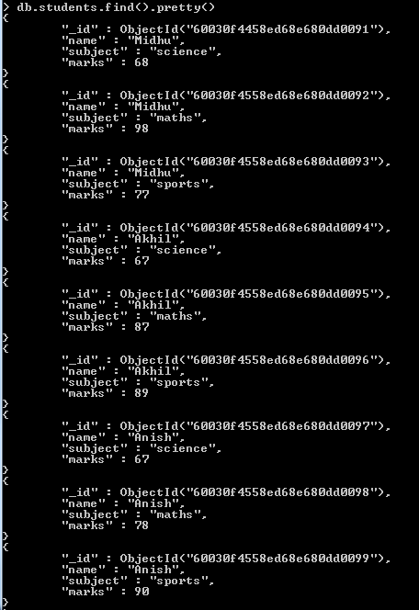

**Exercise: Show Total Marks for Each student in a collection named "totals"**

var mapFunc = function() {

emit(this.name,this.marks);

}

var reduceFunc = function(name,marks) {

return Array.sum(marks);

}

db.students.mapReduce(

mapFunc,

reduceFunc,

{ out: "output" }

)

db.output.find()

